Agenda Notes for discussion in the 114th Meeting of the Unit Approval Committee to be held on 15th July, 2019 at 3.00 P.M. in the Chamber of Development Commissioner, Falta Special Economic Zone at 4th Floor of 2nd MSO Building, Nizam Palace, 234/4, AJC Bose Road, Kolkata-700 20.

A | Action taken report for 113th Meeting of the Unit Approval Committee held on 17th June, 2019 | Page No.3-4
B | Minutes of the 113th Meeting of the Unit Approval Committee held on  17th June, 2019. | Page No. 5-14

Name of the SEZ: FALTA SPECIAL ECONOMIC ZONE

Agenda Item No.1 | New Application for setting up of a SEZ Unit for manufacture of for manufacture of Mica Product at Falta SEZ, Falta applied by M/s. Hi-tech Mica. | Page No.15-17
Agenda Item No.2 | Proposal for inclusion of new items in the existing LOP No. FSEZ/LIC/J-24/2018/541 dated 13.05.2019 applied by M/s. Jagmata Vincom LLP. | Page No.18
Agenda Item No.3 | Request for inclusion of additional items in the existing LOP No.  FSEZ/LIC/P-28/2003/1314 dated 22.05.2003 under ITC(HS) Code  No.7307 92 10, 8547 90 20, 7326 90 80 and 8536 90 30 applied  by M/s. Patton International Limited. | Page No.19- 21

Name of the SEZ:Candor Kolkata One Hi-tech Structures Private Limited IT/ITES SEZ

Agenda Item No.4 | Request of M/s. Accenture Solutions Pvt. Limited for inclusion of additional space as expansion of their unit under the existing LOA. | Page No.22
Agenda Item No.5 | Request of M/s. Cognizant Solutions India Private Limited for inclusion of additional space as expansion of their unit under the existing LOA. | Page No.23
Agenda Item No.6 | Request of M/s. MET Technology Pvt. Limited for shrinking the office area | Page No.24

Monitoring of Annual Performance of SEZ Units located at Falta SEz, Falta

Sl.No. | Name of the Unit | Period of Monitoring | Page No.
1. | M/s. M.P. Industries | 2017-18 – 2nd Block (1st Year.) &  2018-19- 2nd Block (2nd Year) | 25-26
2. | M/s. Websol Energy System Limited | 1st Block [ 2009-10 to 2013-14]  2nd Block [ 2014-15-2018-19] | 27-30
3. | M/s. Dr. KPC Life Sciences Pvt. Limited | 2017-18 -2nd Block(1st Year) | 31-32
4. | M/s. Cresmac Foundry Pvt. Ltd. | 2017-18 & 2018-19- 4th Block  (4th & 5th Year) | 33-34
5. | M/s. CRI Limited | 2018-19- 1st Block(5th Year) | 35-36
6. | M/s. Carbide Cutting Tools Pvt. Limited | 2017-18- 5th Block (1st Year) | 37-38
7. | M/s. DRK Metallurgical Pvt. Ltd. | 2018-19- 3rd Block(3rd Year) | 39-40

Action taken report of 113th Meeting of the Unit Approval Committee held on
17th June, 2019 at 11.00 A.M. in the Chamber of Development Commissioner, Falta Special Economic Zone at 4th floor, 2nd MSO Building, Nizam Palace, 234/4, AJC Bose Road, Kolkata-700 020.

Name of the SEZ: FALTA SPECIAL ECONOMIC ZONE

Agenda Item No.1 | New Application for setting up of a SEZ Unit for manufacture of for manufacture of Handicraft items of Jute, Handicraft items of Brass & Handicraft items of Copper.) at Falta SEZ, Falta applied by M/s. Ved Vaani Crafts Private Limited. | Action taken
Agenda Item No.2 | Request for Transfer of Capital Goods applied by M/s. Ganesh Steel Impex LLP, a manufacturing unit of Falta SEZ, holding LOP NO.FSEZ/LIC/G-20/2018/5076 dated 03.01.2019. | Action taken
Agenda Item No.3 | Request for Addition of new ITC(HS) Code in the LOA applied by M/s. Delta Plus (India) Pvt. Ltd., a manufacturing unit of Falta SEZ, holding LOP NO.FSEZ/LIC/D-12/98/9804 dated 16.01.1998. | Action taken
Agenda Item No.4 | Request for Merger of LOP of M/s. Delta Plus (India) Pvt. Ltd. has requested to merge their LOA No. FSEZ/LIC/D-12/1998/9804 dated 16.01.1998(Unit-II) into LOA No. FSEZ/LIC/D-20/2005/7171 dated 07.01.2005 (Unit-I) | Action taken
Agenda Item No.5 | Request for inclusion of various ITC(HS) Code in the existing LOA of M/s. AP Fashions Pvt. Ltd., as a manufacturing unit of Falta SEZ, holding LOP NO.FSEZ/LIC/A-37/2000/10835 dated 18.01.2000 | Action taken
Agenda Item No.6 | Proposal of M/s. Mittal Technopack Pvt. Ltd. for setting up a new  unit in Falta SEZ at Falta. | Action taken

Name of the SEZ:Candor Kolkata One Hi-tech Structures Private Limited IT/ITES SEZ

Agenda Item No.7 | Request of M/s. Ada Software Re Engineering Services Pvt. Ltd. a unit at Candor Kolkata One Hi-Tech Structures (P) Ltd. IT/ITES holding LOA Nos. SEZ/LIC/A-1/20172020 dated 19.12.2017 | Action taken
Agenda Item No.8 | Request of M/s. Accenture Solutions Pvt. Ltd, a unit at Candor Kolkata One Hi-Tech Structures Pvt. Ltd has requested vide their letter dated 22.5.2019 for inclusion of additional space admeasuring 36274 sq.ft. in addition to their existing occupying space of 41,662 sq.ft. | Action taken
Agenda Item No.9 | Application of M/s. Clean Max Cogen Solutions Pvt. Ltd for setting up of a Special Economic Zone Unit at Candor Kolkata One Hi-tech Structures Pvt. Ltd /ITES Rajarhat, Kolkata. | Action taken
Agenda Item No.10 | Request of M/s. MPS Interactive Systems Limited for de-bonding of their unit from SEZ located at M/s. Candor Kolkata SEZ. | Action taken

Monitoring of Annual Performance of SEZ Units located at Falta Sez, Falta

Sl.No. | Name of the Unit | Period of Monitoring | Remarks | Status
1. | M/s. Dutch Tech Tools Pvt. Ltd. | 2017-18 – 2nd Block (4th Yr.) | (+) NFE taken Note off | Noted
2. | M/s. Sai Industries Pvt. Ltd. | 2017-18 and 2018-19 (3rd year & 4th year of 4th Block) | (+) NFE taken Note off | Noted

Name of the SEZ: Manikanchan Special Economic Zone

Agenda Item No.11 | Monitoring of Annual Performance of M/s B.C. Jain Overseas Pvt. Ltd. for the FY 2015-16, 2016-17 and 2017-18 have applied for exit from Manikanchan SEZ. | Action taken
Agenda Item No.12 | Exit of M/s Jewel India Private Limited from Manikanchan SEZ regarding. | Action taken
Agenda Item No.13 | Non-performance of M/s Modern International, M/s Rohit Export Jewellery LLP and M/s B.C. Sen & Co.– regarding. | Action taken

Additional Agenda

Name of the SEZ: FALTA SPECIAL ECONOMIC ZONE

Agenda Item No.14 | Application of M/s. Fabon Engineering Pvt. Limited for setting up a new unit in Falta SEZ | Action taken

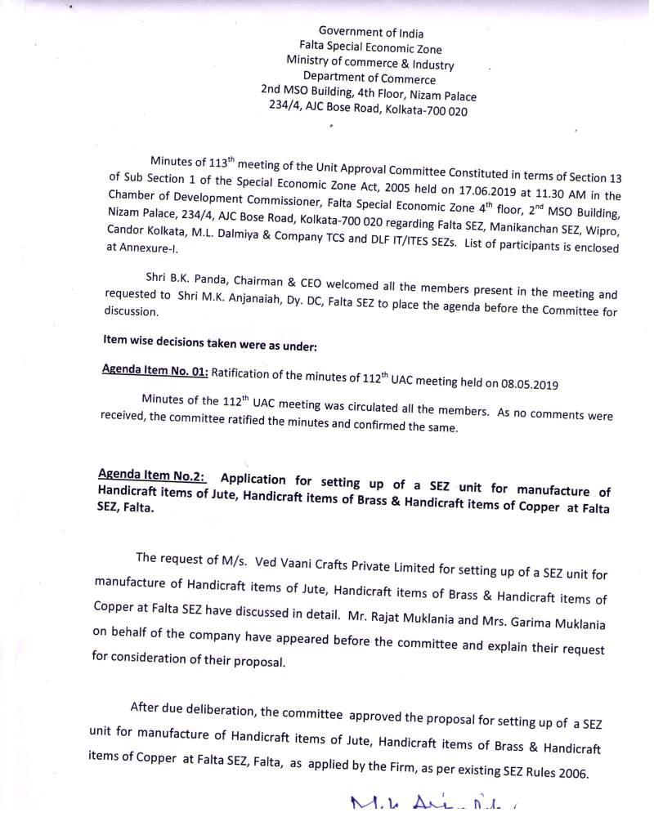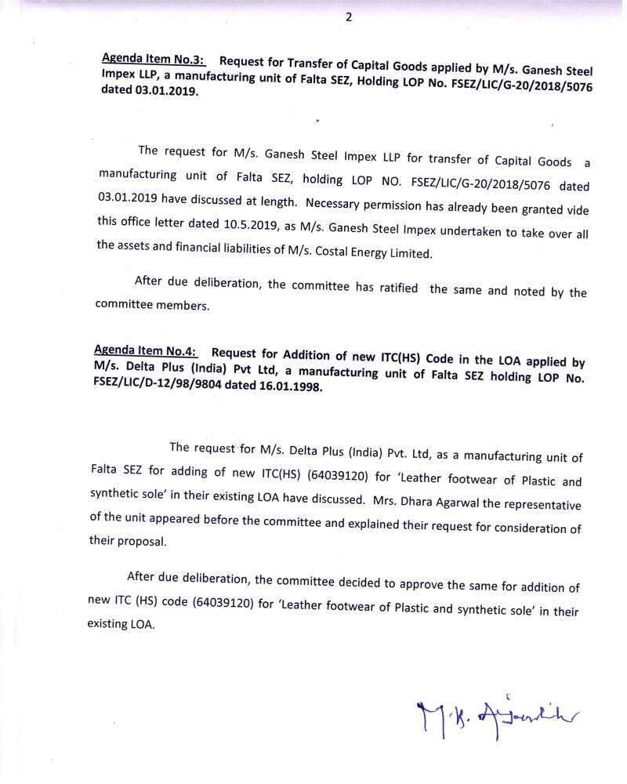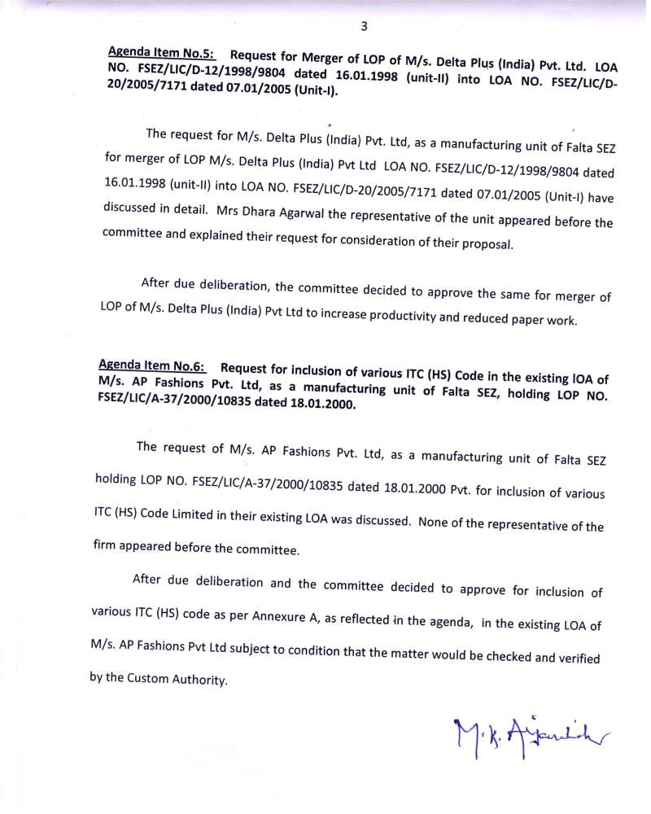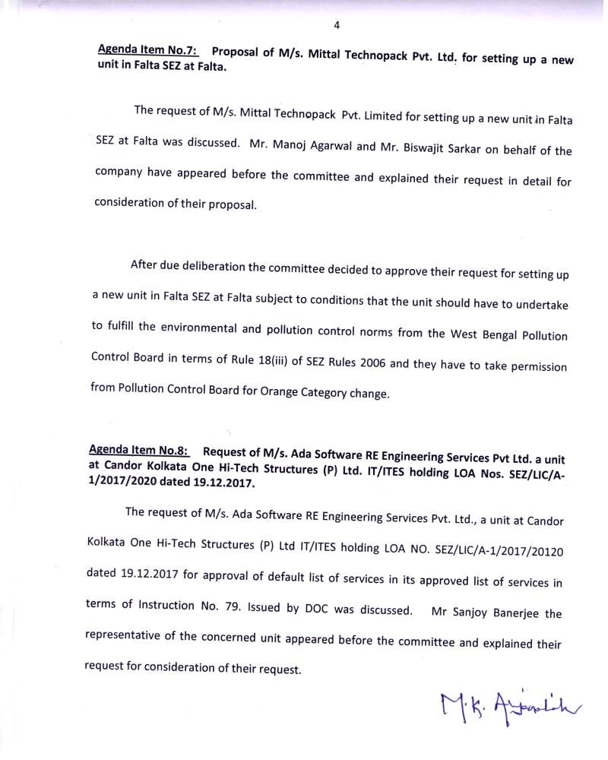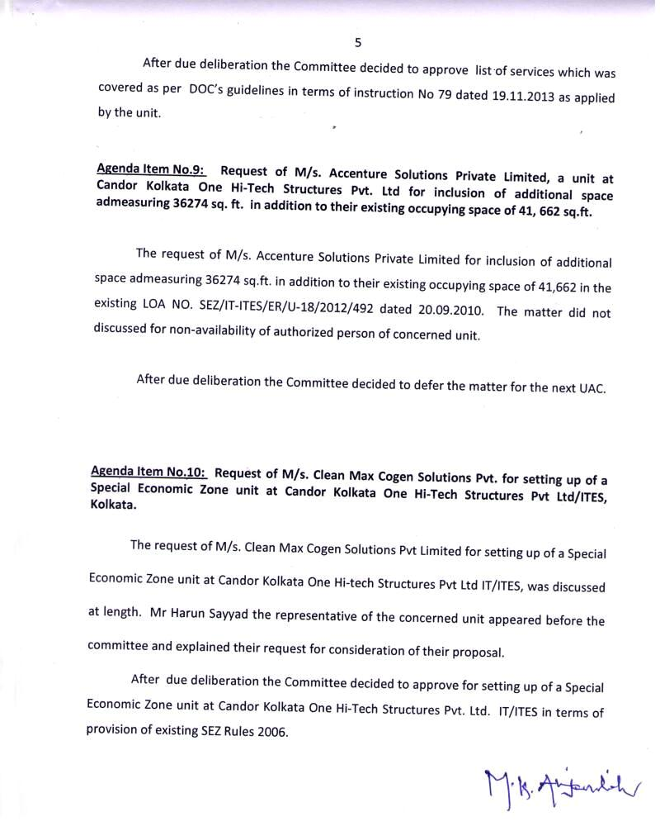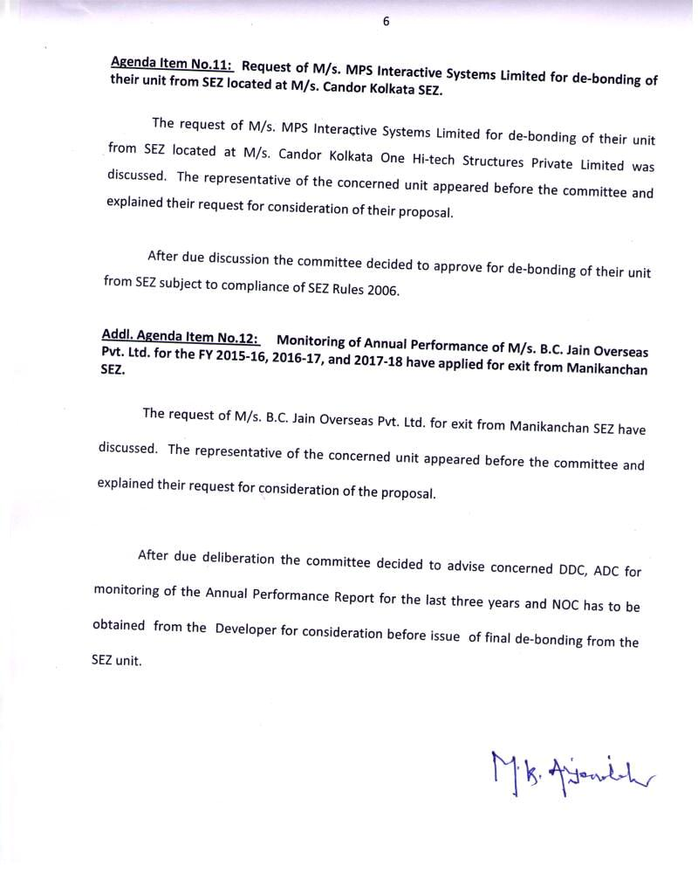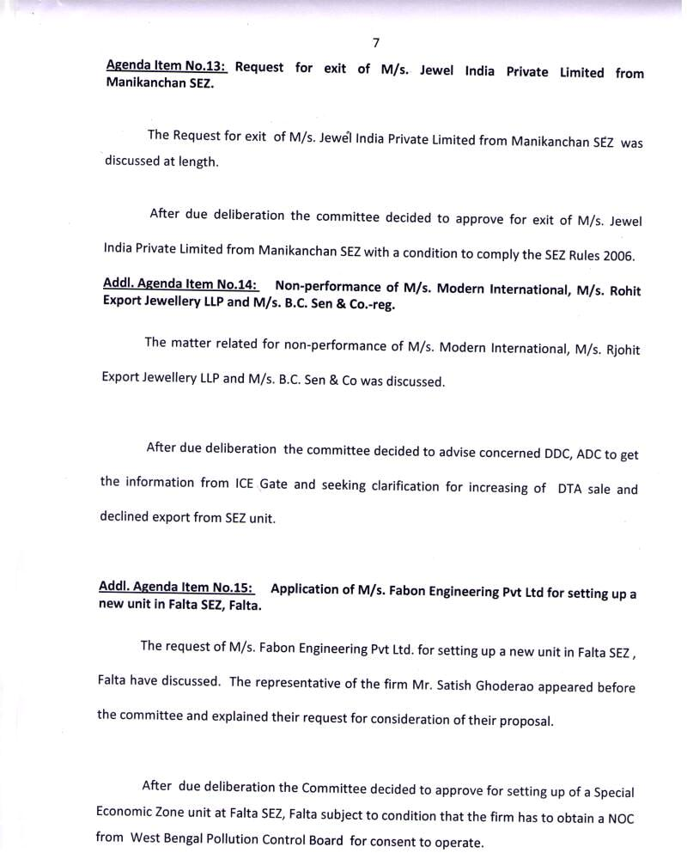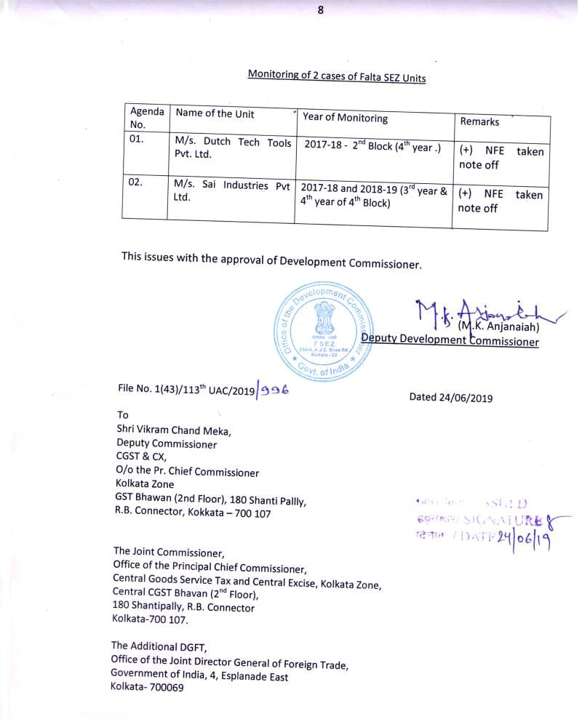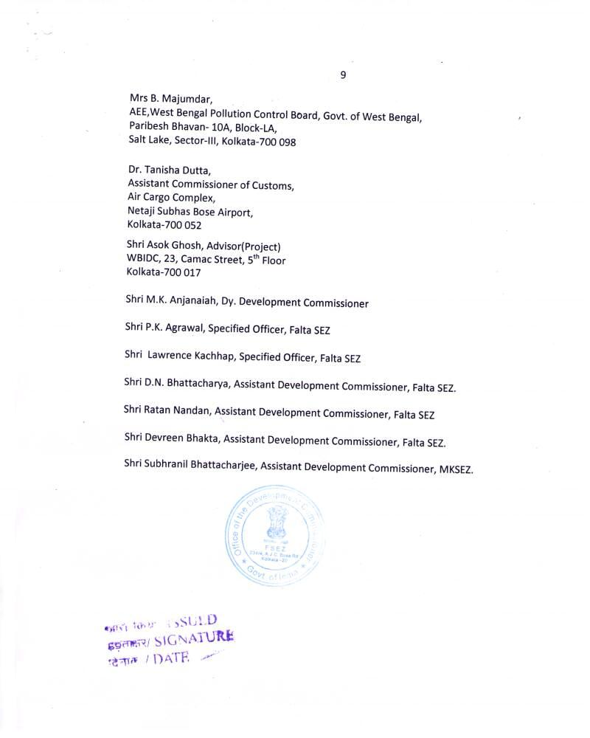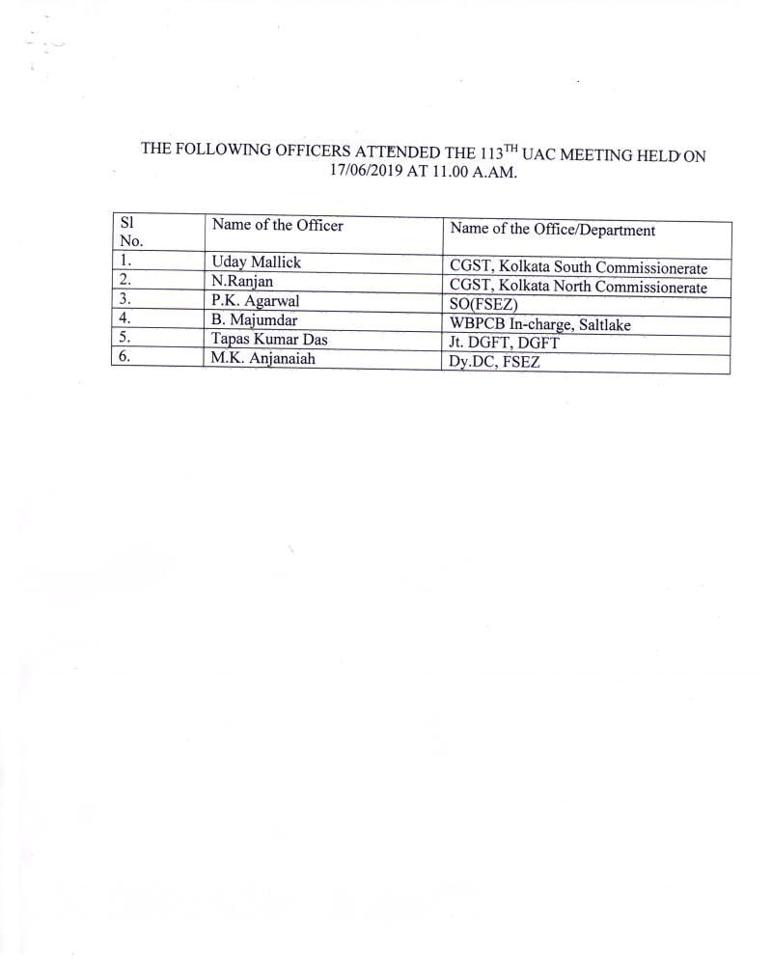

FALTA SPECIAL ECONOMIC ZONE

Agenda Item No.1

114th UAC Meeting to be held on 15.07.2019.

Sub:- Application of M/s. Hitech Mica has submitted a for setting up of a new unit at Falta SEZ.

M/s. Hitech Mica vide its letter dated 11.06.2019 has submitted an application for setting up a new unit in Form F. As per Rule 17 of SEZ Rules, 2006 for setting up of a new unit at Falta SEZ the following documents have to be submitted such as Application Fees, IEC, Name of Director, Certificate from ROC, Investment, Employment etc. On examination of documents, it is found that the firm has not submitted all the required documents. However, a check list is furnished below:

1. | Name of the applicant unit and Regd./Head Office address |  | M/s. Hitech Mica  28-B Shakespeare Sarani, Neelamber Building,  6th Floor, Flat No. 6C  Kolkata -700017,  Phone No. 91-33-4044-7016/19,  Email address- hitechmicakol@gmail.com
2. | About Company/Firm/ Directors/ Promoters |  | This is Partnership Company. Following are the Directors :  1. Shri Ratan Kumar Awarwala  1A Cornfield Road,  Kolkata-700019  Mob: 91 9830042601  Email address- hitechmicakol@gmail.com  2. Shri Rahul Awarwala  1A Cornfield Road,  Kolkata-700019  Mob: 91 9831078321  Email address- hitechmicakol@gmail.com
3. | Whether the applicant has been issued any industrial licence or LOI/LOA under EOU/SEZ/STP/EHTP Scheme. If so, give full particulars, namely reference No., date of issue, items of manufacture and progress of implementation of each project (Refer Para XII(i) of Form F of SEZ Rules, 2005 |  | Hi-tech Information & Marketing Pvt. Ltd. Having different two units under Jurisdiction of Falta SEZ Vide LOP vide No. FEPZ/LIC/H-7/4026 dated 27.07.1999 and No. FSEZ/LIC/H-19/2011/2633 dated 14.09.2011. The units has engaged in manufacture of Mica splitting & Mica Paper.
4. | Whether proof of address/residence of promoter(s) has been furnished/ Nature of the documents to be indicated |  | Copies of Aadhar  Ratan Kumar Agarwala – 4021 3863 1421  Rahul Agarwala – 3929 6459 8298
5. | Whether copies of IT Returns of Proprietor/All Partners/Directors for last 3 years or audited balance sheet for last 3 years in case of companies have been furnished |  | IT Return of Directors for last three years submitted.
6. | Classification of the items proposed for manufacturing/services as per ITC(HS) Classification  Production capacity |  | Mica Product  4750 Tons
7. | Classification of the items proposed for manufacture/services figure in the objective of Memorandum & Articles of Association/Partnership Deed. If yes, in which part |  | No
8. | Whether the proposal envisages permission for sub-contracting part production in DTA |  | No
9 | In case of Partnership firm, the partnership Deed is registered or not |  | No
10 | Marketing tie-up/arrangement envisaged? |  | No
11 |  | Requirement of power | 40 KW)
12 |  | Requirement of build-up area | 10000 sq. Fts.
13 |  | Requirement of land | 4000 sq. mtrs.
14 |  | Whether provisional offer of allotment for space from the Developer enclosed | N.A
15. |  | Investment in plant and machinery:  - Indigenous | Rs. 141.00 Lakhs
16 |  | Financial arrangement envisaged, source of finance including financial status of promoters(s) | 70% Bank Loan  30% own arrangement
17 |  | Investment | Rs. 141.00 Lakhs
18 |  | FOB value of exports during the first 5 years | (Rs.in Lakhs)  1st year 2035.95 INR  2nd year 2326.80 INR  3rd year 2617.65 INR  4th year 2908.50 INR  5th Year 2908.50 INR  Total Rs. 12797.40 Lakhs
19 |  | Foreign Exchange Out go during the first 5 years | Nil
20. |  | Cumulative NFE on the basis of foreign exchange of outflow and inflow | Rs. 12797.40 Lakhs
21. |  | Whether the items proposed to be manufactured envisage pollution? | Non Hazardous Material
21. |  | Whether proposal is for manufacturing, trading or services | Manufacturing
22. |  | Whether Foreign Technology agreement envisaged | No
23. |  | Whether then applicant or any of the Partner/Director who are also Partners/Directors or another company or firm its associate concerns are being proceeded against or have been debarred from getting any license/letter of Intent/Letter of Permission under Foreign Trade (Development and regulation) Act, 1992 or Foreign Exchange Management Act, 1999 or Customs Act, 1962 or Central Excise Act, 1944 (Refer Para XII(ii) or FORM ‘F’ of SEZ Rules, 2006 | No
25. |  | Share holding pattern | NA
26. |  | Whether application has been received online | No
27. |  | Employment | Male -31  Female-95  Total= 126
28. |  | Rule Provision | As per Rule 19 of SEZ Rules, 2006 the Approval Committee may approve or approve with modification a proposal placed under it.

Hence, the matter is placed before UAC for discussion/consideration.

FALTA SPECIAL ECONOMIC ZONE

Agenda Item No.2

114th UAC meeting to be held on 15.07.2019

Sub: Proposal for inclusion of new items in the existing LOP No. FSEZ/LIC/J-24/2018/541 dt 13.05.19 in respect of M/s. Jagmata Vincom LLP.

1 | Name of the Unit | M/s. Jagmata Vincom LLP
2. | Registered Office Address | 28, Strand Road, 1st Floor, Room No. 110  Kolkata -700001,
3 | Location of the Unit | FTWZ at , Falta SEZ
4. | Letter of Permission No. & Date | FSEZ/LIC/J-24/2018/541 dated 13.05.2019
5 | Nature of the unit | Merchant Exporter as per IEC
6. | Items of trading | Warehousing for Fabric Garments
7 | Item to be included | Machinery Part, Lubricants, Shoes and it accessories, luggage, back packs .
8 | Date of Commercial Production | Not Started
9 | LOP valid up to | 12.05.2020
10 | Name of the Proprietor | 1. Shri Pramod Nahata -Director  2. Namita Nahata -Director

Hence the matter is placed before the committee for discussion/decision in this regard.

FALTA SPECIAL ECONOMIC ZONE

Agenda Item No.3
114th UAC Meeting to be held on 15.07.2019
Sub : Request for inclusion of additional items under ITC(HS) Code No. 7307 92 10, 8547 90 20, 7326 90 80 and 8536 90 30.

M/s. Patton International Ltd , a unit in Falta SEZ, engaged in manufacture and export of Zinc Plated (Galvd) Steel Locknut, Zinc Plated (Galvd) Steel clamps, Zinc Plated (Galvd) conduit hanger, Aluminium Locknuts, Alloy steel wire, steel pipe fittings etc, located at Falta SEZ, Falta holding Letter of Permission (LOP) No. FSEZ/LIC/P-28/2003/1314 dated 22.05.2003 has applied for inclusion of additional items under ITC (HS) Code No. 7307 92 10, 8547 90 20, 7326 90 80 and 8536 90 30. The particulars of the unit are as follows:-
1. | Name of the Unit | M/s. Patton International Limited
 | Name of the Directors | H.P.Budhia, Sanjay Budhia, Smt. Minu Budhia, Smt Uma Budhia.
2. | Registered Office Address | 3C, Camac Street, Kolkata-700 016
3 | Location of the Unit | Land-16000 sq.mtr. 4100 sq.mtr. 800 sq.mtr and 200 sq mtr. Industrial Shed, Falta SEZ.
4. | Letter of Permission No. & Date | FSEZ/LIC/P-28/2003/1314 dated 22.05.2003
5. | Existing items of manufactured approved in LOP | Annexed at – Annexure-A
6. | Request for inclusion of new items vide letters dated 11.07.2019 | HS Code Products Annual Capacity (M.T.)  7307 92 10 8547 90 20 7326 90 80 8536 90 30 Steel Pipe Fittings (Galvanized) Steel Pipe Fittings (Galvanized)- Insulated Other Articles of Iron/Steel Junction Box 500 500 500 500
7. | Date of Commencement of Commercial Production | 01.03.2006
8. | LOP valid up to | 28.02.2021
9. | Whether achieve (+)ve NFE | (+)NFE
10. | APR for the year 2017-18 furnished ? | Not yet monitored.
11. | Performance of Export activity (Rs. In Crore) | Year FOB value of export Total outflow Cumulative NFE  2013-14 78.13 2.82 320.11  2014-15 93.87 3.60 90.27  2015-16 120.83 116.76 207.03  2016-17 126.55 8.56 534.24  2017-18 112.87 4.88 642.22

Now, the unit has requested to include four additional items viz. Steel Pipe Fittings (Galvanised) Steel Pipe Fittings (Galvanised)-Insulated, Other Articles of Iron/Steel and Junction Box HS Code 7307 92 10, 8547 90 20, 7326 90 80 and 8536 90 30 and clarified the reasons for inclusion of new items are as follows:-
- They have developed new items as per customer requirement.

- They have planned to procure Raw Material domestically for the above mentioned export item.

- The unit does not required new Machinery as their existing machines can produce the said item.

- They have intimated that generation of employment, investment, projected Export Turnover and change of NFE will depend on volume of Business.

- The unit has not require additional space.

- The Country of Export of New item: USA, Saudi Arabia and Mexico.

Hence, the matter is placed before the UAC Meeting for discussion.

Annexure-A
The following items of manufactured has been approved as per LOP including inclusion of additional items.
DESCRIPTION | EXISTING ITC(HS) CODE | AMENDED ITC (HS) CODE
Zinc Plated (Galvanised) Romex Connectors (Packed in card board carton then palletized in wooden pallet) | 730799.01 | 73079110
Febricated Steel, Hardware made of CR wide Coil (one –hole strap) | 731816.00 | 73089090
Fabricated Steel Hardware made of CR Wide Coil (Two-hole strap) | 731816.00 | 73089090
Steel Clamp (Galvanised) | 730799.01 | 73089090
Febricated Steel Hardware made of CR Sheets (Switch Box) | 830214.03 | 73089090
Builders Hardware : Zinc Plated (Galvd) Conduit Hangers made of Mild Steel. | 830214.03 | 73089090
Steel pipe fittings made from ERW Steel Tubes(Galvanised) | 730799.01 | 73079110
Alloy Steel Wires | 721290.00 | 73129000
Fabricated Steel hardware made of CR Sheets (Reducing Washer) Galvanised. | 731816.00 | 73182200
Galvanised Steel Pipe fittings |  | 73079910
Steel Pipe fittings- others |  | 73079990
Galvanised Steel Pipe |  | 73079910
Steel Pipe Fittings-others |  | 73079990

M/s. Candor Kolkata One Hi-Tech Structures Private Ltd. IT/ITES SEZ

Agenda Item No.4

114th UAC Meeting to be held on 15.07.2019.

Sub: -Request of M/s. Accenture Solutions Pvt. Ltd for inclusion of additional space as expansion of their unit under the existing LOA.

M/s. Accenture Solutions Pvt Ltd, a unit at Candor Kolkata One Hi-Tech Structures Pvt. Ltd has requested vide their letter dated 22.5.2019 for inclusion of additional space admeasuring 36274 sq.ft. in addition to their existing occupying space of 41,662 sq.ft. of their unit in the existing LOA No. SEZ/IT-ITES/ER/U-18/2012/492 dated 20.09.2010. The proposal of the unit is examined as follows:

1. Project Foreign Exchange Balance Sheet for the next 5 years:

Next five years finance details | Year 1 | Year 2 | Year 3 | Year 4 | Year 5 | Total
FOB Value of Exports | 2,133 | 4,806 | 4,806 | 4,806 | 4,806 | 21,358
Foreign Exchange Outgo | 435 | 240 | 240 | 240 | 240 | 1,397
Net Foreign Exchange | 1,698 | 4,566 | 4,566 | 4,566 | 4,566 | 19,962

- The Developer has issued letter of Intent for the said allocating area.
- Proposed employment for the next 5 years - 347

The request is placed before the UAC for consideration.

M/s. Candor Kolkata One Hi-Tech Structures Private Ltd. IT/ITES SEZ

Agenda Item No.5

114th UAC Meeting to be held on 15.07.2019.

Sub: -Request of M/s. Cognizant Solutions India Private Limited for inclusion of additional space as expansion of their unit under the existing LOA.

M/s. Cognizant Solutions India Private Limited, a unit at Candor Kolkata One Hi-Tech Structures Pvt. Ltd has requested vide their letter dated 27.7.2019 for inclusion of additional space admeasuring 241,445 sq.ft. in addition to their existing occupying space of 39,418 sq.ft. of their unit in the existing LOA No. SEZ/LIC/C-12(Unitech)/2012/2094 dated 03.09.2012. The proposal of the unit is examined as follows:

1. Project Foreign Exchange Balance Sheet for the next 5 years:

Next five years finance details | Year 1 | Year 2 | Year 3 | Year 4 | Year 5 | Total
 | 2017-18 | 2018-19 | 2019-20 | 2020-21 | 2021-22
FOB Value of Exports | - | - | - | 13,414.87 | 25,871.53 | 39.286.40
Foreign Exchange Outgo |  |  |  | 2,141 | 3,187 | 5,328.64
Net Foreign Exchange |  |  |  | 11,273.38 | 22,684.38 | 33,957.76

- The Developer has issued letter of Intent for the said allocating area.
- Proposed employment for the next 5 years - Male 1562 Female 938

The request is placed before the UAC for consideration.

M/s. Candor Kolkata One Hi-Tech Structures Private Ltd. IT/ITES SEZ

Agenda Item No.6

114th UAC Meeting to be held on 15.07.2019.

Sub: -Request of M/s. Met Technology Pvt. Ltd. for shrinking the office area.

M/s. Met Technology Pvt. Ltd., a unit at Candor Kolkata One Hi-Tech Structures Pvt. Ltd IT/ITES SEZ has requested vide their letter dated 11.7.2019 for shrinking of their office which is non-operational admeasuring 3934 sq.ft. out of total leased areas 10962 sq.ft. to their existing LOP NO. FSEZ/LIC/M-1/2016/140. The proposal is examined as follows:-

- Existing Space - 10962 sq. ft.

- Space to be vacated- 3934 sq.ft.

- Reason for reduction-

- Area they intent to vacant consists of entertainment room, meditation room, cafeteria, training room, guest room, surplus/ stand-by operational rooms. There will be no reduction in their operational capacity and their projected financials remains intact as they are just shrinking the non-production areas. This will help them to save on the costs and contribute better towards bringing positive foreign exchange flows to India

- Whether projected export performance to be intact?- Yes

- Whether the Developer has given consent? - Yes

The request is placed before the UAC for consideration.

Monitoring of Annual Performance for the Financial Year 2017-18 & 2018-19
1. | Name of the unit | M/s. M.P Industries
2. | Registered Office | 147, M.G. Road, Kolkata -700007.
3. | Name of the Directors/Proprietor | Suresh Kumar Banthia
4. | LOA/LOP No. & Date | FSEZ/LIC/M-49/2011/1873 dated. 10.08.2011
5. | Name of the Service Activities | Umbrella & Umbrella Panel
6. | Date of Commencement of Service Activities | 31.07.2012
7. | Validity of LOA/LOP | 30.01.2023
8. | Monitored Upto | FY 2016-17
9. | Block to be monitored | 2017-18 1st Year of 2nd Block  2018-19 2nd Year of 2nd Block
10 | Realisation pending, if any. | Rs. 148.34 Lakhs
11 | Countries of export as per APR | China, India, UAE

Block since inception:-
1st Block | 2012-13 | 2013-14 | 2014-15 | 2015-16 | 2016-17
2nd Block | 2017-18 | 2018-19

Annual Performance Monitoring Report
(Rs. in Crore)
Year  (1) | FOB Value of Export  (2) | Imported Raw Material consumed during the year  (3) | Amortised Value of Capital Goods  (4) | Other Outflow in foreign currency  (5) | Total Outflow  (6)=3+4+5 | NFE  (7)=[2-6] | Cumulative NFE  (8)
2017-18 | 902.03 | 987.59 | -- | -- | -- | 4.44 | 4.44
2018-19 | 688.94 | 819.30 | -- | -- | -- | -130.36 | -125.92

FOB value of Export:-
Year | Physical Export  (a) | Sales against EEFC A/c.u/s 53A(n)  (b) | Inter-unit sales  (c) | Total FOB value  (d)=a+b+c
2017-18 | 902.03 | -- | -- | 902.03
2018-19 | 688.94 | -- | -- | 688.94

Cases pending for foreign exchange realization, if ay
Year | Pending realization
2018-19 | Rs. 148.34 Lakhs
2017-18 | Rs. 164.29 Lakhs

The matter is placed before UAC for discussion/decision.

Monitoring of Annual performance for the year 2009-10 to 2013-14
1 | Name of Unit | M/s. Websol Energy System Limited.
2 | Registered Office Address | 48, Pramatha Choudhury Sarani, Plot No. 849, Block-“P”, 2nd Floor, New Alipore, Kolkata- 700 053.
3 | Name of the Directors | Mr. Sohan Lal Agarwal, Mr. Sreeram Vasanthi, Mr. Biswa Ranjan Sengupta, Mr. Sushil Kr. Pal & Santosh Kr. Tibrewalla.
4 | LOA No. & Date | No.2(1)/D-10/2005/8606 dated 04.03.2005
5 | Items of Manufacturing | Solar Photovoltaic Cells & Modules, Solar Photovoltaic Systems & Devices, Off-grid, Standalone & Hybrid.
6 | Date of Commencement of Production | 02.06.2009
7 | Validity of LOA | 02.12.2019
8 | Area Allotted | Land 28577
9 | Monitored upto | Nil
10 | Block to be monitored | 1st Block.[2009-10 to 2013-14]
11 | Realization pending | Nil
12 | Countries of Export | Singapore, Europe,

Block since inception
1st Block | 2009-10 | 2010-11 | 2011-12 | 2012-13 | 2013-14
2nd Block | 2014-15 | 2015-16 | 2016-17 | 2017-18 | 2018-19

Annual Performance Monitoring Report
(Rs. in crores)
Year | FOB Value of  Export | Imported Raw Materials consumed during the year | Amortization value of Capital Goods | Other Outflow in foreign currency | Total  Outflow | NFE | Cumulative  NFE
(1) | (2) | (3) | (4) | (5) | (6)3+4+5 | 7=(2-6) | (8)
2009-10 | 105.12 | 54.83 | 7.34 | 0.23 | 62.40 | (+) 42.72 | 42.72
2010-11 | 198.11 | 147.65 | 13.89 | 3.90 | 165.44 | (+) 32.67 | 75.40
2011-12 | 134.92 | 197.35 | 14.19 | 4.09 | 215.63 | (-) 80.71 | 5.32
2012-13 | 122.49 | 106.75 | 14.19 | 1.76 | 122.70 | (-) 0.21 | 5.53
2013-14 | 304.57 | 234.21 | 14.42 | 2.38 | 251.01 | (+) 53.56 | 48.03
5th year of operation in 1st block +ve NFE Cumulatively.
FOB Value of Export(Rs. in crores)
Year | Physical Exports | Sales against EEFC A/C U/S 53(I) | Export as per SEZ Rule 53(m) | Total FOB value
(a) | (b) | © | (d) | (d)=(b)+(c)+(d)
2009-10 | 105.07 | 0.05 | -- | 105.12
2010-11 | 187.26 | 8.60 | 2.25 | 198.11
2011-12 | 112.26 | 18.88 | 3.78 | 134.92
2012-13 | 2.88 | 94.32 | 25.29 | 122..49
2013-14 | 271.09 | 33.18 | 0.30 | 304.57

Imported Raw materials (Rs. in Crores)
Year | CIF Value of Raw materials | Value of import from other SEZ/EOU unit | Value of import Raw materials transferred to other SEZ | Total value of import of Raw materials. | Value of import raw materials consumed
(a) | (b) | (c) | (d) | (e) | (f)
2009-10 | 93.91 | -- | -- | 93.91 | 54.83
2010-11 | 194.17 | -- | -- | 194.17 | 147.65
2011-12 | 123.01 | -- | -- | 123.01 | 197.35
2012-13 | 112.31 | -- | -- | 112.31 | 106.75
2013-14 | 238.93 | -- | -- | 238.93 | 234.21

Imported Capital Goods(Rs. in crores)
Year | CIF Value of Capital goods end of the year | Capital goods received from other unit | Capital goods transferred to other unit | Total value of import of capital goods. | Amortized value of Capital Goods.
(a) | (b) | (c) | (d) | (e) | (f)
2009-10 | 88.05 | -- | -- | 88.05 | 7.34
2010-11 | 138.85 | -- | -- | 138.85 | 13.89
2011-12 | 141.89 | -- | -- | 141.89 | 14.19
2012-13 | 141.89 | -- | -- | 141.89 | 14.19
2013-14 | 144.22 | -- | -- | 144.22 | 14.42

Cases pending for Foreign Exchange Realization as per APR
Year | Pending Realization**  (Rs. In Crore) | Cumulative Pending Realization (in Crore)
2009-10 | Nil | Nil
2010-11 | Nil | Nil
2011-12 | Nil | Nil
2012-13 | Nil | Nil
2013-14 | Nil | Nil

** As confirmed vide Units’ letter dated 28/5/2019
Other information as per APR
Year | Investment in Zone  (Rs. In Crore) | Employment
2009-10 | 151.77 | 275
2010-11 | 232.73 | 269
2011-12 | 237.90 | 250
2012-13 | 237.97 | 314
2013-14 | 240.35 | 369

Monitoring of Annual performance for the period of
2014-15 to 2018-19

1 | Name of Unit | M/s. Websol Energy System Limited.
2 | Registered Office Address | 48, Pramatha Choudhury Sarani, Plot No. 849, Block-“P”, 2nd Floor, New Alipore, Kolkata- 700 053.
3 | Name of the Directors | Mr. Sohan Lal Agarwal, Mr. Sreeram Vasanthi, Mr. Biswa Ranjan Sengupta, Mr. Sushil Kr. Pal & Santosh Kr. Tibrewalla.
4 | LOA No. & Date | No.2(1)/D-10/2005/8606 dated 04.03.2005
5 | Items of Manufacturing | Solar Photovoltaic Cells & Modules, Solar Photovoltaic Systems & Devices, Off-grid, Standalone & Hybrid.
6 | Date of Commencement of Production | 02.06.2009
7 | Validity of LOA | 02.12.2019
8 | Area Allotted | Land 28577
9 | Monitored upto | Nil
10 | Block to be monitored | 2nd Block.[2014-15 to 2018-19]
11 | Realization pending | Nil
12 | Countries of Export | Singapore, Europe,

Block since inception
1st Block | 2009-10 | 2010-11 | 2011-12 | 2012-13 | 2013-14
2nd Block | 2014-15 | 2015-16 | 2016-17 | 2017-18 | 2018-19

Annual Performance Monitoring Report
(Rs. in crores)
Year | FOB Value of  Export | Imported Raw Materials consumed during the year | Amortization value of Capital Goods | Other Outflow in foreign currency | Total  Outflow | NFE | Cumulative  NFE
(1) | (2) | (3) | (4) | (5) | (6)3+4+5 | 7=(2-6) | (8)
2014-15 | 355.75 | 298.52 | 15.29 | 0.13 | 313.94 | 41.81 | 41.81
2015-16 | 276.73 | 208.76 | 15.84 | 0.18 | 224.78 | 51.95 | 93.76
2016-17 | 295.17 | 180.76 | 20.47 | 0.55 | 201.78 | 93.39 | 187.15
2017-18 | 183.16 | 120.02 | 22.93 | 0.02 | 142.97 | 40.19 | 227.34
2018-19 | 70.35 | 54.11 | 23.01 | -- | 77.12 | (6.77) | 220.57
5th year of operation in 2nd block +ve NFE Cumulatively.
FOB Value of Export(Rs. in crores)
Year | Physical Exports | Sales against EEFC A/C U/S 53(I) | Inter Units Sales  53(m) | Total FOB value
(a) | (b) | © | (d) | (d)=(B)+(C)+(d)
2014-15 | 72.18 | 246.46 | 37.11 | 355.75
2015-16 | 35.80 | 240.93 | -- | 276.73
2016-17 | 1.47 | 293.70 | -- | 295.17
2017-18 | 7.83 | 175.33 | -- | 183.16
2018-19 | 0.10 | 70.25 | -- | 70.35
Imported Raw materials(Rs. in crores)
Year | CIF Value of Raw materials | Value of import from other SEZ/EOU unit | Value of import Raw materials transferred to other SEZ | Total value of import of Raw materials. | Value of import raw materials consumed
(a) | (b) | (c) | (d) | (e) | (f)
2014-15 | 300.47 | -- | -- | 300.47 | 298.52
2015-16 | 191.40 | -- | -- | 191.40 | 208.76
2016-17 | 176.40 | -- | -- | 176.40 | 180.76
2017-18 | 125.31 | -- | -- | 125.31 | 120.02
2018-19 | 61.50 | -- | -- | 61.50 | 54.11

Imported capital goods(Rs. in crores)
Year | CIF Value of Capital goods end of the year | Capital goods received from other unit | Capital goods transferred to other unit | Total value of import of capital goods. | Amortized value of Capital Goods.
(a) | (b) | (c) | (d) | (e) | (f)
2014-15 | 152.90 | -- | -- | 152.90 | 15.29
2015-16 | 158.37 | -- | -- | 158.37 | 15.84
2016-17 | 204.68 | -- | -- | 204.68 | 20.47
2017-18 | 229.27 | -- | -- | 229.27 | 22.93
2018-19 | 230.17 | -- | -- | 230.17 | 23.01

Cases pending for Foreign Exchange Realization as per APR
Year | Pending Realization**  (Rs. in Creore) | Cumulative Pending Realization (in Crore)
2014-15 | Nil | Nil
2015-16 | Nil | Nil
2016-17 | Nil | Nil
2017-18 | Nil | Nil
2018-19 | Nil | Nil
** As confirmed vide unit’s letter dated 28/05/2019
Other information as per APR
Year | Investment in Zone  (Rs. in crore) | Employment
2014-15 | 249.03 | 380
2015-16 | 249.03 | 380
2016-17 | 224.77 | 314
2017-18 | 388.10 | 409
2018-19 | 256.84 | 248

Annual Performance Report for the FY 2017-18
1. | Name of the Unit | M/s. Dr.KPC Life Sciences Pvt. Ltd.
2. | Registered Office Address | Sector-II, Falta SEZ, PO-Bishira, South 24 Pgs, Falta.
3. | Name of the Director (s) | - Kali Pradip Chaudhuri  - Rajat Kumar Ray  - Anil Chandra Ghosh  - Krishna Das
4. | LOA No. & Date | FSEZ/LIC/C-31/2007/6708 dated 29.03.2007
5. | Item of manufacturing | Research and Development unit on Biotechnology, drugs and pharmaceuticals including Manufacturing of new products by way of research and synthesizing of molecules.
6. | Date of Commencement of Production | 27.09.2012
7. | Area Allotted | Land 4884 Sq.mtr., Sec-II
8. | LOP validity | 25.09.2022
9. | Monitored up to | 2016-17
10 | Block to be monitored | 2017-18 – 2nd Block (1st Yr.)
11 | Pending Realization as per APR | ---
12 | Country of export as per APR | Canada

Block since inception :-
1st | 2012-13 | 2013-14 | 2014-15 | 2015-16 | 2016-17
2nd | 2017-18

Annual Performance Monitoring Report
Year  (1) | FOB Value of Export  (2) | Imported Raw Material consumed during the year  (3) | Amortised value of Capital Goods  (4) | Other outflow in foreign currency  (5) | Total outflow  6=3+4+5 | NFE  (Rs. in Crore)  7=(2-6) | Cumulative NFE  (Rs. in Crore)  (8)
2017-18 | 0.058 | 0.052 | 0.045 | - | 0.097 | (-)0.039 | (-)0.039

FOB Value of Export
(Rs. in Crore)
Year | Physical Exports  (a) | Sales against EEFC A/C u/s 53A(n)  (b) | Inter-unit Sales  © | Total FOB Value  (d)=(a)+(b)+(c)
2017-18 | 0.058 | --- | -- | 0.058

Cases pending for Foreign Exchange Realization as per APR

Year | Pending Realization  ( Rs. in Crore) | Cumulative Pending Realization (in crore)
2017-18 | Nil | Nil

Other Information as per APR :-

Year | Investment in Zone  (Rs. in Crore) |  | Employment
 | Building | Plant & Machinery
2017-18 | 12.56 |  | 27

Annual Performance Report for the FY 2017-18 & 2018-19
1. | Name of the Unit | M/s. Cresmac Foundry Pvt. Ltd.
2. | Registered Office Address | Sector-II, Falta SEZ, PO-Bishira, South 24 Pgs, Falta.
3. | Name of the Director (s) | - Clair Barton Anderson  - Haik Hyrapiet Sookias  - Haik Hyrapiet Sookias Junior  - Gautam Banerjee  - Eric Collins Anderson  - Suzanna Kay Anderson  - Jon Joseph Anderson
4. | LOA No. & Date | FEPZ/LIC/M-6/1997/1426 dated 09.06.1997
5. | Item of manufacturing | Industrial Casting
6. | Date of Commencement of Production | 01.01.2000
7. | Area Allotted | Land 21500 Sq.mtr.
8. | LOP validity | 31.12.2019
9. | Monitored up to | 2016-17
10 | Block to be monitored | 2017-18 & 2018-19– 4th Block (4th & 5th Yr.)
11 | Pending Realization as per APR | ---
12 | Country of export as per APR | USA etc.

Block since inception :-
1st | 1999-00 | 2000-01 | 2001-02 | 2002-03 | 2003-04
2nd | 2004-05 | 2005-06 | 2006-07 | 2007-08 | 2008-09
3rd | 2009-10 | 2010-11 | 2011-12 | 2012-13 | 2013-14
4th | 2014-15 | 2015-16 | 2016-17

Annual Performance Monitoring Report
Year  (1) | FOB Value of Export  (2) | Imported Raw Material consumed during the year  (3) | Amortized value of Capital Goods  (4) | Other outflow in foreign currency  (5) | Total outflow  6=3+4+5 | NFE  (Rs. in Crore)  7=(2-6) | Cumulative NFE  (Rs. in Crore)  (8)
2014-15 | 27.31 | 3.74 | 0.54 | 0.15 | 4.43 | 22.89 | 22.89
2015-16 | 25.48 | 3.90 | 0.52 | 0.00 | 4.42 | 21.05 | 43.94
2016-17 | 28.23 | 3.63 | 0.53 | 0.02 | 4.18 | 24.05 | 67.99
2017-18 | 29.61 | 4.84 | 0.45 | 1.76 | 7.05 | 22.56 | 90.55
2018-19 | 45.62 | 6.08 | 0.55 | 0.03 | 6.66 | 38.96 | 129.51

FOB Value of Export
(Rs. in Crore)
Year | Physical Exports  (a) | Sales against EEFC A/C u/s 53A(n)  (b) | Inter-unit Sales  © | Total FOB Value  (d)=(a)+(b)+(c)
2017-18 | 29.61 | --- | -- | 29.61
2018-19 | 45.62 | --- | -- | 45.62

Cases pending for Foreign Exchange Realization as per APR

Year | Pending Realization  ( Rs. in Crore) | Cumulative Pending Realization (in crore)
2017-18 | Nil | Nil
2018-19 | Nil | Nil

Other Information as per APR :-
Year | Investment in Zone  (Rs. in Crore) |  | Employment
 | Building | Plant & Machinery
2017-18 | 4.35 | 16.74 | 231
2018-19 | 4.60 | 18.34 | 237

Annual Performance Report for the FY 2018-19
1. | Name of the Unit | M/s. CRI Ltd.
2. | Registered Office Address | Premises No.333, Mahamayatalla, Garia Main Road, Garia, Kolkata-700084.
3. | Name of the Director (s) | - Priti A Sureka  - Raj Kumar Goenka  - Shivani Agarwal  - Radhey Shyam Jhanwar  - Debashish Bhaumik  - Rohin Raj Sureka  - Avishi Sureka
4. | LOA No. & Date | FSEZ/LIC/C-33/2013/447 dated 01.05.2013
5. | Item of manufacturing | Tips for Ball Pen refills, Blanks for Ball pen tips
6. | Date of Commencement of Production | 08.04.2014
7. | Area Allotted | SDF 300 Sq.mtr.
8. | LOP validity | 07.04.2019
9. | Monitored up to | 2017-18
10 | Block to be monitored | 2018-19– 1st Block (5th Yr.)
11 | Pending Realization as per APR | ---
12 | Country of export as per APR | ---

Block since inception :-
1st | 2014-15 | 2015-16 | 2016-17 | 2017-18

Annual Performance Monitoring Report
Year  (1) | FOB Value of Export  (2) | Imported Raw Material consumed during the year  (3) | Amortised value of Capital Goods  (4) | Other outflow in foreign currency  (5) | Total outflow  6=3+4+5 | NFE  (Rs. in Crore)  7=(2-6) | Cumulative NFE  (Rs. in Crore)  (8)
2014-15 | 20.15 | 18.40 | --- | --- | 18.40 | 1.75 | 1.75
2015-16 | 19.00 | 17.45 | --- | --- | 17.45 | 1.55 | 3.30
2016-17 | 6.95 | 6.38 | --- | --- | 6.38 | 0.58 | 3.88
2017-18 | --- | --- | --- | --- | --- | --- | 3.88
2018-19 | --- | --- | --- | --- | ---- | ---- | 3.88

FOB Value of Export
(Rs. in Crore)
Year | Physical Exports  (a) | Sales against EEFC A/C u/s 53A(n)  (b) | Inter-unit Sales  © | Total FOB Value  (d)=(a)+(b)+(c)
2018-19 | ---- | --- | -- | ----

Cases pending for Foreign Exchange Realization as per APR

Year | Pending Realization  ( Rs. in Crore) | Cumulative Pending Realization (in crore)
2018-19 | Nil | Nil

Other Information as per APR :-

Year | Investment in Zone  (Rs. in Crore) |  | Employment
 | Building | Plant & Machinery
2018-19 | -- | 0.09 | Nil

Note : Unit has requested for de-bonding their unit at FSEZ vide their letter dt.16/03/2017 and subsequent Deficiency Letter issued to the unit vide this office letter dated 27.04.2017 & 28.07.2017. But, the unit has not complied with the same till date.
Annual Performance Report for the FY 2017-18

1. | Name of the Unit | M/s. Carbide Cutting Tools Pvt. Ltd.
2. | Registered Office Address | Plot No.21A, Sector-I, FSEZ, Falta, West Bengal.
3. | Name of the Director (s)/Proprietor | - Kazumasa Koike  - Jiro Osawa  - Norio Ishikawa  - Michael Dean Grantham  - Yasutaka Yoneda  - Nobukai Osawa
4. | LOA No. & Date | FEPZ/LIC/C-12/97/4242 dated 09.01.1997
5. | Item of manufacturing | Industrial Drills/End Mills/Bars/Routers/Centre Drills/Special Tools/Finished Taps
6. | Date of Commencement of Production | 01.10.1997
7. | Area Allotted | Land-7913 Sq.mtr.
8. | LOP validity | 30.09.2022
9. | Monitored up to | 2016-17
10 | Block to be monitored | 2017-18– 5th Block (1st Yr.)
11 | Pending Realization as per APR | ---
12 | Country of export as per APR | USA, Germany, England etc.

Block since inception :-
1st | 1997-98 | 1998-99 | 1999-2000 | 2000-01 | 2001-02
2nd | 2002-03 | 2003-04 | 2004-05 | 2005-06 | 2006-07
3rd | 2007-08 | 2008-09 | 2009-10 | 2010-11 | 2011-12
4th | 2012-13 | 2013-14 | 2014-15 | 2015-16 | 2016-17
5th | 2017-18

Annual Performance Monitoring Report
Year  (1) | FOB Value of Export  (2) | Imported Raw Material consumed during the year  (3) | Amortised value of Capital Goods  (4) | Other outflow in foreign currency  (5) | Total outflow  6=3+4+5 | NFE  (Rs. in Crore)  7=(2-6) | Cumulative NFE  (Rs. in Crore)  (8)
2017-18 | 29.54 | 15.35 | 2.84 | 0.19 | 18.38 | 11.16 | 11.16

FOB Value of Export
(Rs. in Crore)
Year | Physical Exports  (a) | Sales against EEFC A/C u/s 53A(n)  (b) | Inter-unit Sales  © | Total FOB Value  (d)=(a)+(b)+(c)
2017-18 | 29.54 | --- | -- | 29.54

Cases pending for Foreign Exchange Realization as per APR

Year | Pending Realization  ( Rs. in Crore) | Cumulative Pending Realization (in crore)
2017-18 | Nil | Nil

Other Information as per APR :-

Year | Investment in Zone  (Rs. in Crore) |  | Employment
 | Building | Plant & Machinery
2017-18 | 9.06 | 57.20 | 118

Annual Performance Report for the FY 2018-19
1. | Name of the Unit | M/s. DRK Metallurgical Pvt. Ltd.
2. | Registered Office Address | 37B, Garcha Road, Near Ballygunge Phari, Kolkata-700019.
3. | Name of the Director (s)/Proprietor | - Ajoy Kumar Bose  - Rajat Kapoor  - Raghu Raj Kapoor
4. | LOA No. & Date | FSEZ/LIC/D-21/2005/776 dated 09.05.2005
5. | Item of manufacturing | Ferro Vanadium, Ferro Molybdenum, Ferro Tungsten, Ferro Nickel and Cobalt Oxide.  Items included :-  Ferro Titanium, LC Ferro Chrome (30.10.2009);  Molybdenum Concentrate – High Grade, Tungsten Concentrate –High Grade, Sodium Tungstate, Vanadium Pentoxide –High Grade, Ammonia Metavanadate (08.10.2013);  Processed Special Metal Scrap e.g. Titanium, Nickel, Tungsten, Molybdenum, Cobalt Scrap as Backward integration, SLAG (production Process) (25.06.2013)
6. | Date of Commencement of Production | 31.05.2006
7. | Area Allotted | Land-5445 Sq.mtr.
8. | LOP validity | 31.05.2021
9. | Monitored up to | 2017-18
10 | Block to be monitored | 2018-19– 3rd Block (3rd Yr.)
11 | Pending Realization as per APR | Nil
12 | Country of export as per APR | Brazil,Germany, Singapore etc.

Block since inception :-
1st | 2006-07 | 2007-08 | 2008-09 | 2009-10 | 2010-11
2nd | 2011-12 | 2012-13 | 2013-14 | 2014-15 | 2015-16
3rd | 2016-17 | 2017-18 | 2018-19

Annual Performance Monitoring Report
Year  (1) | FOB Value of Export  (2) | Imported Raw Material consumed during the year  (3) | Amortised value of Capital Goods  (4) | Other outflow in foreign currency  (5) | Total outflow  6=3+4+5 | NFE  (Rs. in Crore)  7=(2-6) | Cumulative NFE  (Rs. in Crore)  (8)
2016-17 | 3.58 | 6.02 | --- | 0.06 | 6.07 | (-)2.49 | (-)2.49
2017-18 | 20.43 | 13.61 | --- | 0.04 | 13.65 | 6.78 | 4.28
2018-19 | 35.46 | 18.95 | --- | 0.08 | 19.03 | 16.43 | 20.71

FOB Value of Export
(Rs. in Crore)
Year | Physical Exports  (a) | Sales against EEFC A/C u/s 53A(n)  (b) | Inter-unit Sales  © | Total FOB Value  (d)=(a)+(b)+(c)
2018-19 | 35.46 | --- | -- | 35.46

Cases pending for Foreign Exchange Realization as per APR

Year | Pending Realization  ( Rs. in Crore) | Cumulative Pending Realization (in crore)
2018-19 | Nil | Nil

Other Information as per APR :-

Year | Investment in Zone  (Rs. in Crore) |  | Employment
 | Building | Plant & Machinery
2018-19 | 0.52 | 0.70 | 43

